ZHCXJ Shaping Machine
Operation Instructions
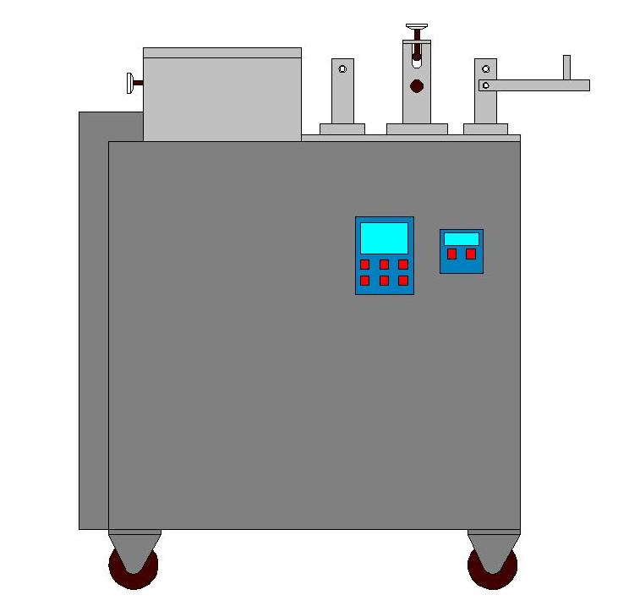
- Thank you for choosing machines from Jinan Zhuoheng Extrusion Machinery Co., Ltd.
- please read this operation instruction before using the machine
- Welcome to inquiry if anything unclear

Jinan Zhuoheng Extrusion Machinery Co., Ltd

I Overview
ZHCXJ Shaping machine is a special foodstuff machine used in fried snacks line, our company engineers manufacture it combined with market demand on the basis of similar equipment at home and abroad. It could make different shapes of fried snacks such as golden moon, crispy fish shape snacks, crispy sala, bugles and so on. The machine is of high automation, easy to use, small footprint, and it is the ideal equipment of increasing the varieties and improving product quality in food industry.
II Machine Structure
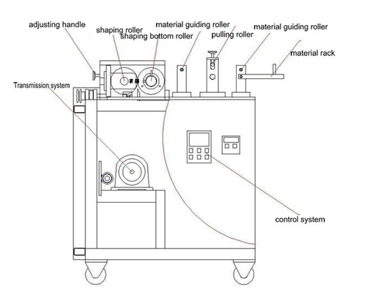
III Equipment Description
1). Function
The function of the shaping machine is making the flakes and tube shape material out from double screw extruder into variety shapes of designs and color by pulling, stretching, shaping and roll cutting. The shaping machine could make golden moon, crispy fish shape snacks, Sala bugles, duck and magic gourd variety shapes of fried flour puffed snacks by changing forming roller knife and shaping of forming roller.
2) Structural features
The shaping machine consists of material guiding part, material pulling part, rolling cut shaping part, Transmission and control part and so on(See attached diagram).Its characteristic is shapes well, De-moulding effect is good and clean, it could make different shapes of fried snacks by changing forming roller, One machine is multi-purpose, its function is all ready. Shaping machine adopts frequency conversion motor; the speed can be adjusted according to the discharging speed of double screw extruder easy to use.
3) Model explanations
ZHCXJ -- I

Code of shaping machine time of improving

4) Main technical parameters
Voltage: Three phases 380V
Power 0.55 Kw
Roller diameter 116mm
Roller knife speed adjustable
Dimension 950×650×980mm (LxWxH)
IV Attentions for Transportation
The shaping machine is mechanical and electrical products should be avoided due to shock and vibration during transport slip collision, overturning phenomenon, we need to adopt appropriate safety measures, such as play packaging fixed base, etc., to ensure that equipment is in good condition.
V Installation and debugging
1 Place the machine on solid ground level, keep ventilation and dry.
2 The power should have control beginning, and have reliably connected ground or zero protection.
3 Fixed good position, should conduct a comprehensive inspection, the other parts are in good condition nondestructive, if there's any loose coupling, make sure the no-load operation
4 Before the operation should regulate the hand wheel adjustment to the next position; put through power supply, check the motor speed regulation is normal, machine without exception
VI Operating procedures and matters needing attention
A: according to the requirements of products, such as golden moon, fish shape snacks and crispy sala bugles snacks products, select the appropriate combination roller and cutter rollers to install in the machine, roller block cover must be fixed immediately.
B: adjust the motor speed to a minimum; speed should be gradually quickly until the match with extruder. The related equipment is working properly, should try to fine or not move, in order to ensure the stability of the products
C: Role of the adjusting handle is to adjust the gap between bottom roller and cutter roller, it is forbidden to use when high speed.
D: When the following situation occurs, please contact us (the manufacturer) in time.
1 Press roller and cutter roller do not run or loud noise.
(a)Check whether the motor is working properly
(b) Check whether the hand wheel is compact, if gear mesh is bad, it will be easy to cause noise.
2 Material winding on the roller or knife roller
(a)Should shut down immediately.
(b)Clean up the roller in the down state then restart.
The shaping machine press roller and cutting roller are of high speed rotating components, when using, must pay attention to safety, remember do not put hand (s) into it illegal operation.
VII Maintenance
1 Regularly check the parts and electrical parts identify problems and timely maintenance.
2 After hours must clean up, to ensure that the next normal use
3 If the machine long time no use, please loosen the hand wheel ; The other components must coat oil protection ，such as gear wheel and so on
4 Regular check the circuit line, prevent from getting an electric shock loose, insulation aging circuit fault.
5Must pay attention to production safety

The Editor:
Thank you for choose the Jinan Zhuoheng Extrusion Machinery; if you company increase product variety or enlarge the production, our company also have other types of equipments for your select. (Reference list). Our company adhering to the "excellent quality, long-last reputation" of the enterprise purpose and "mutual cooperation and common development" business philosophy. Our adhere to the principle of “Sincerity, Innovation and excellence” spirit and dedication, we provide you the good serve and supply on-site installation, commissioning service and free training operators and free offer advanced technology formula and ensure the long-term supply spare parts, the warranty of the machine is for one year free. If there are some problems when need to consult or purchase the spare parts or special order, you can feel free to contact with us, we will meet your requirements as soon as possible.
Thanks again for your using Zhuoheng Extrusion Machinery, Zhuoheng service can bring your convenience and satisfaction, wish have a thriving business and sincerely hope you can propose the ideas and suggestions.

